**PRACTICAL-3**

**AIM:**

1. To change the colour of nodes
2. To create a network with multiple nodes

**Procedure:**

1. **Change colour of nodes.**

**Step 1 :** Open the OMNET++ IDE by typing omnetpp in terminal.

**Step 2:** Create a new project which will be an empty project.

**Step 3 :** OMNET++ uses NED fies to define components and to assemble them into larger unites like networks. To add the file to the project ,right-click the project directory in the Project Explorer panel on the left, and choose New ->Network Description File (NED) from the menu.

**Step 4** : In the source mode of the .ned file, enter the code as in figure.

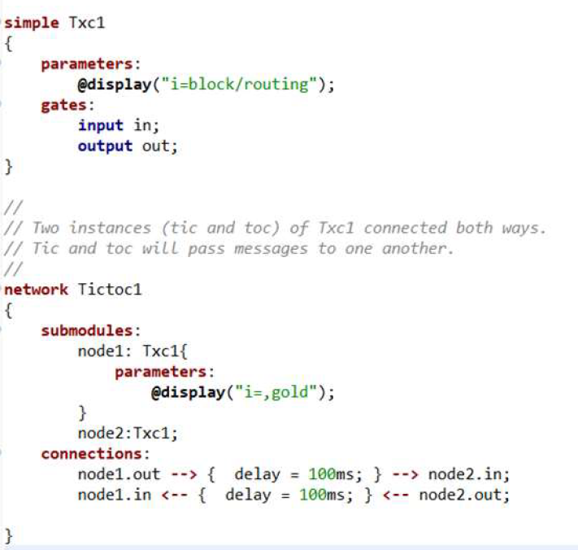

**Result :** Colour of node changed successfully.

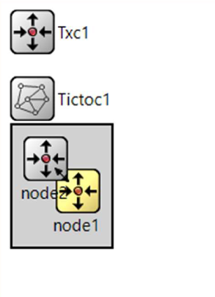

1. **To create a network with multiple nodes.**

**Step 1 :** Open the OMNET++ IDE by typing omnetpp in terminal.

**Step 2:** Create a new project which will be an empty project.

**Step 3 :** OMNET++ uses NED fies to define components and to assemble them into larger unites like networks. To add the file to the project ,right-click the project directory in the Project Explorer panel on the left, and choose New ->Network Description File (NED) from the menu.

**Step 4** : In the source mode of the .ned file, enter the code as in figure.

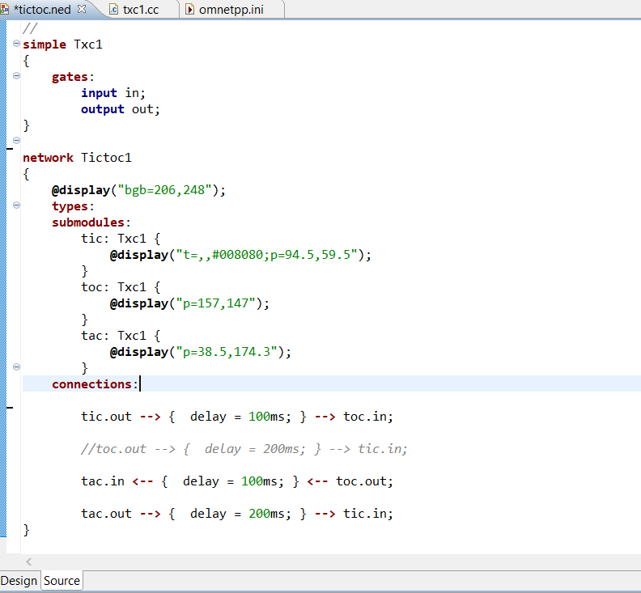

**Step 5 :** We now need to implement the functionality of the Txc1 module in C++. Create a

file by choosing New -> Source File from the project's context menu and give name as per

choice.

**Step 6** : In the C++ source file(.cc extension) , enter the code as in figure.

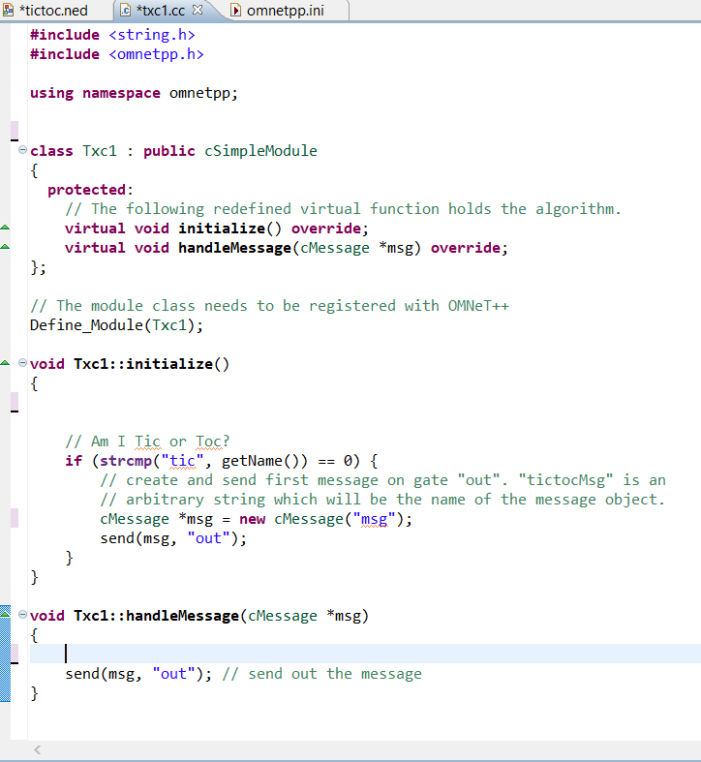

**Step 7:** To be able to run the simulation, we need to create an omnetpp.ini file. omnetpp.ini tells the simulation program which network you want to simulate. Create an omnetpp.ini file using the File -> New -> Initialization file (INI) menu item and enter the code as shown.

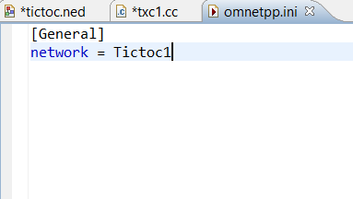

**Step 8 :** Now the code is complete so click on run button to run the simulator.

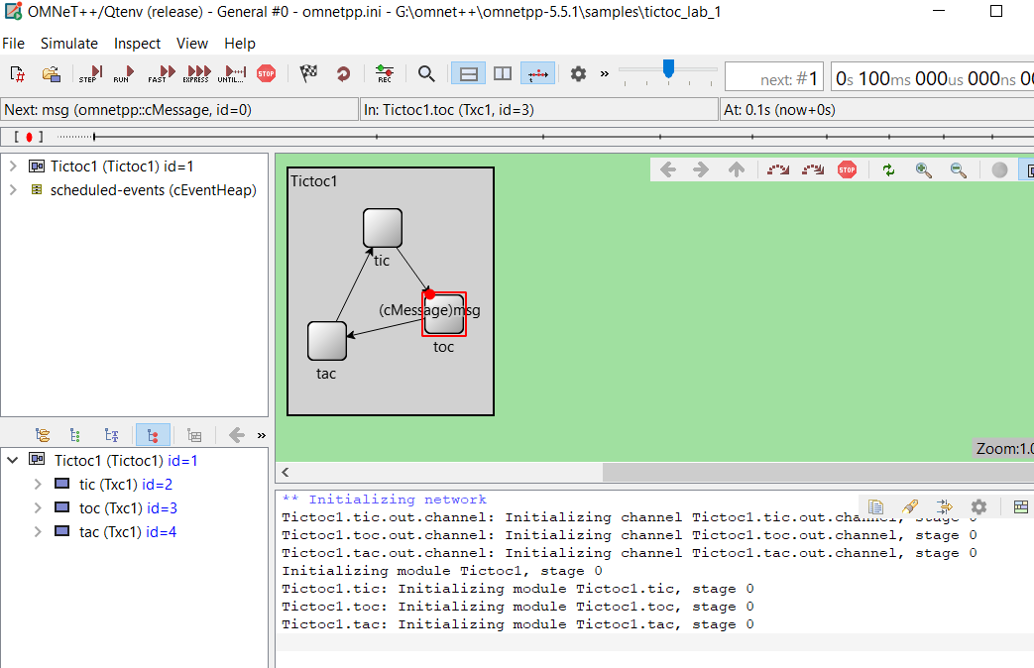

**Step 9:** Network with multiple node is created is implemented successfully.